2020 02 13 NR Daily Log

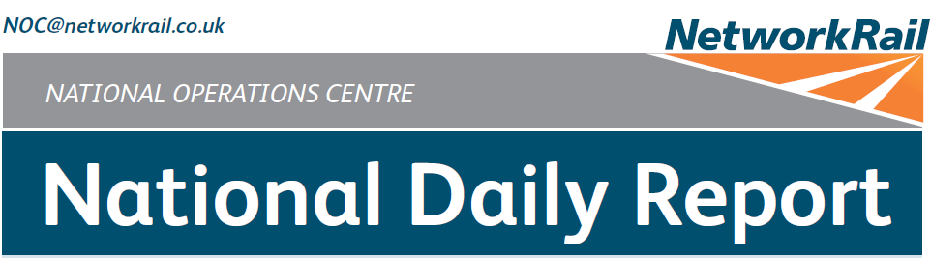



***DATE OF REPORT: NOC MANAGER 0700 – 1900:***

***NOC MANAGER 1900 – 0700:***

***DUTY CONTROLLER 0630 – 1830:***

***DUTY CONTROLLER 1830 – 0630:***

***SUPPORT CONTROLLER 0630 – 1830:***

***SUPPORT CONTROLLER 1830 – 0630:***

***LONDON CONTROLLER 0700 – 1900:***

***LONDON CONTROLLER 1900 – 0700:***

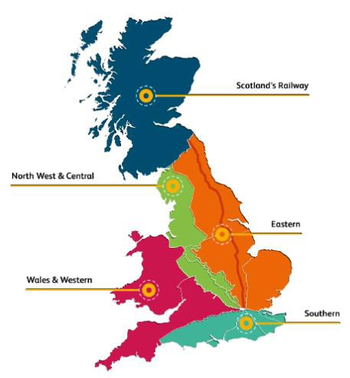

Thursday 13th February 2020 Lucinda Wing

Mark Elkin Bob Scoot Mark Robinson Pete Ure

Graham McIntosh Cornelius Edjah David Newton

***TABLE OF CONTENTS***

1. ***WRONG SIDE FAILURE REPORTS 3***
2. ***SIGNALS PASSED AT RED (CATEGORY ‘A’) 3***
3. ***DERAILMENTS 3***
4. ***COLLISIONS 3***
5. ***TRAIN OR VEHICLE RUNAWAY 3***
6. ***OPERATIONAL INCIDENTS 3***
7. ***TRAINS WITH STRANDED PASSENGERS 4***
8. ***SIGNIFICANT POSSESSION PROBLEMS 4***
9. ***FATALITIES 4***
10. ***INJURIES/ASSAULTS 4***
11. ***NEAR MISSES 4***
12. ***RAILWAY CRIME 4***
13. ***STATION OVERRUNS 4***
14. ***BROKEN RAILS/TRACK DEFECTS 5***
15. ***POWER FAILURES 5***
16. ***POINTS FAILURES 6***
17. ***SIGNALS/SIGNALLING SYSTEMS FAILURES 6***
18. ***TRACK CIRCUIT & AXLE COUNTER FAILURES 6***
19. ***BRIDGE STRIKES 7***
20. ***ROAD VEHICLE INCURSIONS (NON-LEVEL CROSSINGS) 7***
21. ***TRACTION FAILURES 8***
22. ***WEATHER-RELATED PROBLEMS 8***
23. ***FIRES 10***
24. ***WILD REPORTS & HABD ACTIVATIONS 11***
25. ***GROUP STANDARDS GE/RT8250 & GO/RT3350 12***
26. ***TPWS 12***
27. ***MISCELLANEOUS 12***
28. ***REVIEW TABLE 13***
29. ***REAL TIME PERFORMANCE FIGURES 14***

***01 WRONG SIDE FAILURE REPORTS***

# Southern (Sussex) – CCIL 2094212 / Fault No. 159272

At 1639, 1Q76, Colas, 1131 Tonbridge West Yard – Tonbridge West Yard, formed by locomotives 73963

& 73962, intermittently failed to operate ‘MJS’ track circuit on the Down Arun Valley line at Arundel. Locomotive wheels were examined and found to be free from contamination. The Barnham Mobile Operations Manager confirmed at 1816, that there was no contamination on the railhead. In response, the track circuit was treated as defective and regulation 3.5 was implemented. S&T staff were summoned to site to undertake wrong side failure testing, however, testing was deferred till after service due to staff not holding the requisite competencies. Testing was ongoing as this Report closed.

***02 SIGNALS PASSED AT RED (CATEGORY ‘A’)***

None.

***03 DERAILMENTS***

None.

***04 COLLISIONS***

None.

***05 TRAIN OR VEHICLE RUNAWAY***

None.

***06 OPERATIONAL INCIDENTS***

# Eastern (North & East) – CCIL 2093869 / Fault No. 787603

At 0418, it was reported that No. 2997A points on the Up Hull line at Howden had been run through within WON 46 Item 280, Howden LC CCTV - Gilberdyke, all lines blocked, 0105 (Thu) – 0520 (Thu), an LNE Network Operations North managed possession. 6Y21, Freightliner, 0510 Howden – Belmont Down Yard ran through the points in the Reverse position and came to a stand over the points and Howden CCTV Level Crossing. A Mobile Operations Manager and S&T staff were dispatched to site and Humberside Police (ref. 35) were advised about the crossing. The Mobile Operations Manager arrived on site at 0444 and undertook an examination of the points and the train. The Mobile Operations Manager was unable to secure the points with the train in place and authorised the train to proceed at below 5mph. S&T staff arrived on site at 0520 and after initial assessment the points were secured in the Normal position. Authority was granted for the possession to be rescinded and the Up Hull line possession was cancelled at 0608 and the Down Hull line at 0610. A P’Way supervisor was mobilised to site and at 0651 authorised movements at caution on the Up Hull line. The Engineering Supervisor was relieved of duty for ‘for cause’ screening. At 0945, S&T staff authorised normal signalling, additional adjustments to the stretcher bar was undertaken between trains.

|  |  |  |  |  |  |  |  |
| --- | --- | --- | --- | --- | --- | --- | --- |
| TRUST 775616 FDBI | | | | | | | |
| Cancelled | 11 | Part Cancelled | 12 | Trains Delayed | 121 | Minutes | 1162 |

# Eastern (Anglia) – CCIL 2093953

At 0719 Colas reported that the 20 mph ESR on the Down Electric line at Maryland had been removed in error and as a result a 20 mph caution was imposed until re-erection of the 20 mph ESR boards. An investigation was undertaken into the cause of the error. ESR boards were confirmed as in place by 1005.

***07 TRAINS WITH STRANDED PASSENGERS***

|  |  |  |  |  |  |
| --- | --- | --- | --- | --- | --- |
| ***Region / Route*** | ***Train*** | ***Since*** | ***Between*** | ***OUTCOME*** | ***CCIL*** |
| Southern / Kent | 1H90, Southeastern, 0605 Hastings – London Charing Cross | 0625 –  0825 | Battle – Crowhurst | Rescue unit arranged to attach to the rear | 2093929 |
| Eastern / Anglia | 1P03, Greater Anglia, 0530 Norwich – London Liverpool Street | 0635 –  0826 | Manningtree - Colchester | Rescue locomotive arranged | 2093931 |
| North West and Central (NW) | 1R74, East Midlands Railway, 0854 Norwich – Liverpool Lime Street | 1350 -  1450 | Trafford Park Junction – Glazebrook Junction | Train was authorised to return to Manchester Oxford Road for a fitter to secure a loose pipe. | 2094130 |

***08 SIGNIFICANT POSSESSION PROBLEMS***

None.

***09 FATALITIES***

None.

***10 INJURIES/ASSAULTS***

# Wales and Western (Wales) – No CCIL entry

At 0015, it was advised that a member of Cardiff DU P’Way staff had sustained a strained calf whilst lifting rail on Down Main line at Radyr. The member of staff was conveyed home by a colleague, later attending A&E with a family member for assessment.

***11 NEAR MISSES***

# Eastern (Anglia) – CCIL 2094235

At 1905 the driver of 1L12, East Midlands Railway, 1351 Liverpool Lime Street - Norwich, reported a near miss at Leys Lane Footpath Crossing between Eccles Road and Attleborough with a cyclist. The driver sounded the horn and observed the person to clear the crossing. The driver was to continue. The Norwich Mobile Operations Manager was tasked with undertaking a check of the crossing equipment.

***12 RAILWAY CRIME***

None.

***13 STATION OVERRUNS***

# Eastern (East Coast) – CCIL 2094066

At 1129 2C58, Northern, 1053 Hull - Doncaster, formed by unit 158853, comprising two coaches in all, overran Saltmarshe station by 20 feet, returning to the station with permission. The driver stated that the overrun was due to misjudging the braking distance. The driver was fit to continue.

|  |  |  |  |  |  |  |  |
| --- | --- | --- | --- | --- | --- | --- | --- |
| TRUST 776745 TED3 | | | | | | | |
| Cancelled | 0 | Part Cancelled | 0 | Trains Delayed | 2 | Minutes | 23 |

***14 BROKEN RAILS/TRACK DEFECTS***

# Southern (Kent) – CCIL 2094197/ Fault No. 463758

At 1614 the driver of 0B55, DB Cargo, 1515 Wembley Yard – Dollands Moor, reported a dip in the track on the Down Catford Loop line at Nunhead. Services were cautioned at 20 mph with the Mobile Operations Manager and P’ Way staff sent to site. At 1700 the Mobile Operations Manager imposed a 5 mph caution reporting three dips in the track. P’Way staff blocked the line at 1716 due to the severity of the defect, which required grinding and clamping before it could be reopened. Service reductions were imposed with diversions via Herne Hill and Kent House, with ticket acceptance agreed with other operators, LUL and TfL Buses. Arrangements were made for freight services that had passed through the area to have their wheelsets examined. P’Way staff were back on site at 2111 with the requisite equipment and were afforded a Line Blockage. By 2244 the defect had been clamped and a 5 mph ESR was imposed, with all associated ESR equipment confirmed as in place. P’Way staff carried out grinding work after service, with full rectification work planned for this weekend.

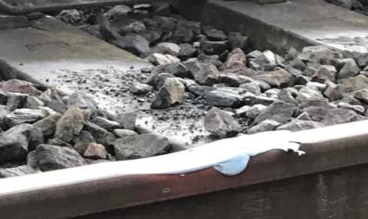 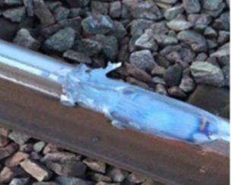

|  |  |  |  |  |  |  |  |
| --- | --- | --- | --- | --- | --- | --- | --- |
| TRUST 777365 IQM2 | | | | | | | |
| Cancelled | 26 | Part Cancelled | 6 | Trains Delayed | 133 | Minutes | 899 |

***15 POWER FAILURES***

# North West and Central (NW) – CCIL 2093855 / Fault No. 881938

At 0308, Crewe ECRO reported a breaker operation on section SX.50 on the Down Bolton line between Ordsall Lane Junction and Lostock Junction. At 0400 the OLE staff arrived on site at Bolton and undertook an inspection of platforms 4 & 5, with nothing found amiss, they continued to inspect the OLE in the section. Services in the Down direction were diverted via the Chat Moss lines where route knowledge allowed or were cancelled and ran as ECS to destination for return workings. Up direction services were not affected. The OLE inspection continued until 0523, when a member of staff advised the discovery of fresh burn marks on cantilever arm at structure MG17/68. An OLE supervisor was requested to site, who arrived at 0533 and undertook an assessment of the damage. An isolation was arranged of section SX.50, sub sections D and E between Clifton and North of Bolton station. At 0649, 2J61, Northern, 0554 Manchester Victoria – Wigan North Western, a diesel service was authorised through the section. The driver reported that the line was fit for diesel traction. Further services were contacted to confirm that they were formed of diesel traction before being authorised into the affected section. Following consultation with Northern and TransPennine Express it was decided to undertake the repairs after the morning peak. Staff for the emergency possession were sourced and an emergency possession was granted at 1018. Following the replacement of the registration arm the possession was cancelled at 1230 and the isolation at 1235, thus allowing normal signalling to resume.

|  |  |  |  |  |  |  |  |
| --- | --- | --- | --- | --- | --- | --- | --- |
| TRUST 775634 IQFM | | | | | | | |
| Cancelled | 36 | Part Cancelled | 15 | Trains Delayed | 141 | Minutes | 1089 |

***16 POINTS FAILURES***

# Eastern (North & East) - CCIL 2093943 / Fault No. 787612

At 0633, Sheffield Sub-ROC Shift Signalling Manager reported a loss of Reverse detection No. 7705 points at Milner Royd Junction blocking the route towards Halifax. A Mobile Operations Manager arrived on site at 0710 just as the signaller had obtained Reverse detection. The points were swung several times successfully, with no problems reported, allowing normal train running to resume. S&T arrived on site at 0813 and carried out an inspection of the points. The fault was placed in order at 1000.

|  |  |  |  |  |  |  |  |
| --- | --- | --- | --- | --- | --- | --- | --- |
| TRUST 775889 IQGG | | | | | | | |
| Cancelled | 0 | Part Cancelled | 2 | Trains Delayed | 87 | Minutes | 794 |

***17 SIGNALS/SIGNALLING SYSTEMS FAILURES***

# Wales and Western (Wales) – CCIL 2094277 / Fault No. 460412

At 1917 the driver of 6B84, Freightliner, 1831 East Usk Yard – Moreton-on-Lugg, reported that AY3 signal on the Up Main line at Abergavenny had reverted from OFF to ON as the train approached. The driver was unable to stop and passed the signal at red. The reversion was caused by the signal lever returning to the frame. The driver was fit to continue.

|  |  |  |  |  |  |  |  |
| --- | --- | --- | --- | --- | --- | --- | --- |
| TRUST 777961 IQWS | | | | | | | |
| Cancelled | 0 | Part Cancelled | 0 | Trains Delayed | 14 | Minutes | 157 |

***18 TRACK CIRCUIT & AXLE COUNTER FAILURES***

# North West and Central (WCMLS) – CCIL 2093127 / Fault No. 881770

At 1823 (Tue), the Shift Signalling Manager at Stoke SCC reported that track circuit ‘145’ on the Up Main line at Hixon had failed. A service was authorised to examine the line and reported nothing seen amiss. The track circuit cleared after the passage of a train. S&T staff were advised and arrived on site at 1900 (Tue) and at 2010 (Tue) reported that they had replaced a fuse but would continue to monitor the track circuit. At 1237 (Wed), the track circuit failed again, holding two signals at red. S&T were mobilised to site but were redirected to a points failure. Services in the Up direction were diverted via Stone and Stafford. Down direction services were not affected. At 1402 (Wed), track circuit ‘161’ failed on the Down Main line, adjacent to track circuit ‘145’ and S&T were again mobilised. At 1544 (Wed), track circuit ‘161’ was cleared, after S&T staff replaced a fuse, allowing normal signalling over the Down Main line. Work continued on fault finding for track circuit ‘145’ until 1633 (Wed), when S&T advised that the issue was with a failed track circuit feed set, but there were no spares within Stafford stores. Staff attempted to carry out a temporary repair without success. At 0904, S&T staff were back on site to fit a replacement track circuit feed set and confirmed at 1100 that the track circuit had been restored but remained on site to observe the passage of traffic. Normal train running was resumed at 1227 after S&T staff had completed final testing.

|  |  |  |  |  |  |  |  |
| --- | --- | --- | --- | --- | --- | --- | --- |
| TRUST 771246 IQNT (since 11/02/20) | | | | | | | |
| Cancelled | 0 | Part Cancelled | 0 | Trains Delayed | 171 | Minutes | 1201 |

# Wales and Western (Western) – CCIL 2093844 / Fault No. 460340

At 0138 (Thu) the Plymouth signaller reported that axle counters ‘RW’ and ‘RY’ on the Down Main line and ‘NY’ and ‘NZ’ on the Up Main line between St Germans and Liskeard were showing failed after a lightning storm in the area. The axle counters would not reset and trains being authorised past two signals on the Up Main line and one signal on the Down Main line at red. At 0345 S&T discovered three blown fuses with replacements obtained from the depot at Par. A temporary repair was undertaken but this did not resolve the issue. Further parts were replaced allowing the axle counters to be reset at 1145. Normal signalling resumed.

|  |  |  |  |  |  |  |  |
| --- | --- | --- | --- | --- | --- | --- | --- |
| TRUST 775513 XQDZ | | | | | | | |
| Cancelled | 4 | Part Cancelled | 0 | Trains Delayed | 82 | Minutes | 831 |

***18 TRACK CIRCUIT & AXLE COUNTER FAILURES (CONT.)***

# Southern (Sussex) – CCIL 2094041 / Fault No. 159254

At 1022 Three Bridges ROC Shift Signaller Manager reported that ‘OG’ & ‘OF’ axle counters had failed on the Up Brighton Fast line. The axle counters were initially reset but then failed again after the passage of a train. Services were diverted to the Up Slow line or cautioned past two signals on the Up Brighton Fast line with S&T staff sent to site. S&T staff arrived on site at 1102 and were afforded Line Blockages to investigate the fault. At 1130 S&T staff reported that an axle counter head required replacement. By 1229 the axle counter head had been changed, with the axle counters restored at 1235 to allow normal signalling to resume.

|  |  |  |  |  |  |  |  |
| --- | --- | --- | --- | --- | --- | --- | --- |
| TRUST 776602 IQBF | | | | | | | |
| Cancelled | 14 | Part Cancelled | 8 | Trains Delayed | 94 | Minutes | 625 |

# North West and Central (North West) - CCIL 2094130 / Fault No. 882007

At 1350, Manchester ROC Shift Signalling Manager advised that axle counters MCFN, MCFS, MCFT and MCRB, on the Down Oxford Road/CLC line between Deansgate and Trafford Park, had failed after the passage of 1R74, East Midlands Railway, 0856 Norwich – Liverpool Lime Street. As a result, there was no route available from Deansgate to Ordsall Lane. The driver of 1R74 reported at 1403, that a pipe was hanging down from the front bogie of unit 153384 and was granted a Line Blockage to secure the pipe. At 1417, 1C55, Northern, 1328 Manchester Airport – Barrow-in-Furness was utilised to reset the axle counters MCFN and MCFS on the Down Oxford Road successfully, allowing the route from Deansgate to Ordsall Lane to become available. 1R74 returned to Manchester Oxford Road at 1421 (See section **07** and of this Report), where it was met by a fitter. At 1508, the Shift Signalling Manager confirmed that 1F98, Northern, 1349 Manchester Airport – Liverpool Lime Street had successfully reset axle counters MCFT and MCRB, allowing normal train running to resume.

|  |  |  |  |  |  |  |  |
| --- | --- | --- | --- | --- | --- | --- | --- |
| TRUST 777054 MEM3 | | | | | | | |
| Cancelled | 1 | Part Cancelled | 5 | Trains Delayed | 218 | Minutes | 1791 |

***19 BRIDGE STRIKES***

|  |  |  |  |  |  |  |  |
| --- | --- | --- | --- | --- | --- | --- | --- |
| ***Region / Route*** | ***Time*** | ***Location*** | ***Bridge No.*** | ***Dispensation*** | ***NWR*** | ***CCIL*** | ***TRUST*** |
| North West and Central (NW) | 1029 | Clitheroe | HOK/60 | R | 1124 | 2093509 | 776551, XQFO = 1 Cancelled = 2 Pt cancelled. |

***20 ROAD VEHICLE INCURSIONS (NON-LEVEL CROSSINGS)***

None.

***21 TRACTION FAILURES***

Please see section **18** of this report in reference to 1R74, East Midlands Railway, 0856 Norwich - Liverpool Lime Street which required fitter attendance to a loose pipe.

# Eastern (Anglia) – CCIL 2094159

At 1413 the driver of 1K77, Greater Anglia, 1233 Norwich – Stansted Airport formed by unit 755410, reported that they were seeking guidance from their fleet department due to multiple alarms sounding within the driving cab at Audley End. Trains trapped in rear were worked clear, with services started/terminated at Cambridge. A block to traffic for services departing London Liverpool Street for Cambridge was implemented at 1528. The driver attempted to gain traction in diesel mode, but this was unsuccessful and the train was declared a failure. An assisting locomotive 1Z99 was identified at Norwich, departing at 1535. A fitter was on site at 1642 but was unable to restore power to the unit. The assistance arrived on site at 1741, with the combined train on the move at 1811 as 5K99, after the fitter had rectified an issue with the brakes.

|  |  |  |  |  |  |  |  |
| --- | --- | --- | --- | --- | --- | --- | --- |
| TRUST 777206 MEB4 | | | | | | | |
| Cancelled | 15 | Part Cancelled | 19 | Trains Delayed | 91 | Minutes | 667 |

***22 WEATHER-RELATED PROBLEMS***

# Southern (Wessex) – CCIL 2093874 / Fault No. 463690

At 0445 the Havant workstation 2 signaller reported being unable to lower the barriers at Warblington Station CCTV Level Crossing with one barrier appearing to be distorted by the wind. The road lights were working correctly and trains were cautioned over the crossing. Havant S&T staff discovered that the Down Side facing barrier boom had snapped off at the bolts. Hampshire police were advised and a road closure was arranged whilst repairs were carried out. Repairs were carried out during the morning but delays were encountered removing the old seized bolts from the boom. The boom was replaced and signaller authorised to work normally from 1145, with further remedial work to be carried out overnight.

|  |  |  |  |  |  |  |  |
| --- | --- | --- | --- | --- | --- | --- | --- |
| TRUST 775637 1QCX | | | | | | | |
| Cancelled | 0 | Part Cancelled | 0 | Trains Delayed | 128 | Minutes | 659 |

# Southern (Kent) – CCIL 2093929/ Fault No. 463701

At 0625 the driver of 1H90, Southeastern, 0605 Hastings – London Charing Cross, reported that the train had struck a large tree on the Up Hastings line between Crowhurst and Battle, with the tree blocking both lines. The train, formed by units 375709, 375910 & 375617, sustained an air leak with a fitter requested to attend. A Mobile Operations Manager and Off Track staff were sent to site. The traction current was discharged on both lines at 0642 to allow the driver to examine the train. Arrangements were made for the train in rear, 1H92, Southeastern, 0616 Ore - London Charing Cross to be utilised to rescue the 56 passengers. At 0749 the traction current was restored to allow 1H92 to commence movement towards 1H90. The transfer of passengers was complete at 0825, with the passengers returned to West St Leonards at 0859 for alternative forward transport. The tree and debris was removed by Off Track staff and clear of the line at 0832. A locomotive was sent from Tonbridge Yard to assist the failed unit however this was not required due to the fitter managing to release the brakes on the unit. The affected unit was made safe by the fitter and went forward at 40 mph at 0943 to Tonbridge, with the route subsequently reopened at 0954.

|  |  |  |  |  |  |  |  |
| --- | --- | --- | --- | --- | --- | --- | --- |
| TRUST 775907 XQMD | | | | | | | |
| Cancelled | 17 | Part Cancelled | 30 | Trains Delayed | 93 | Minutes | 709 |

***22 WEATHER-RELATED PROBLEMS (CONT.)***

# Eastern (Anglia) – CCIL 2093931 / Fault No. 305324

At 0635 the driver of 1P03, Greater Anglia, 0530 Norwich – London Liverpool Street, reported striking an object on the OLE on the Up Main line between Manningtree and Colchester. The driver further reported a flash and a bang, with the ECRO confirming a tripping of OLE section 341 which would not reset. A Mobile Operations Manager and OLE staff were sent to site. Arrangements were made for a service on the Down line to undertake an examination of the line. A rescue locomotive was made ready to assist. Additional staff were sourced for the implementation of Single Line Working if deemed practical. At 0742 the OLE Supervisor confirmed that a tree had come down onto the OLE, damaging the outer running wire to the balance weight, catenary wire and the return conductor. The rescue locomotive attached to 1P03 at 0816. 1P03 was on the move at 0826 to Colchester. All affected trains were cleared from the area allowing repair work to commence from 1203, with an initial estimate of 5 ½ hours for restoration. All works were completed by 1707 with the route reopened at 1745 after all equipment had been cleared.

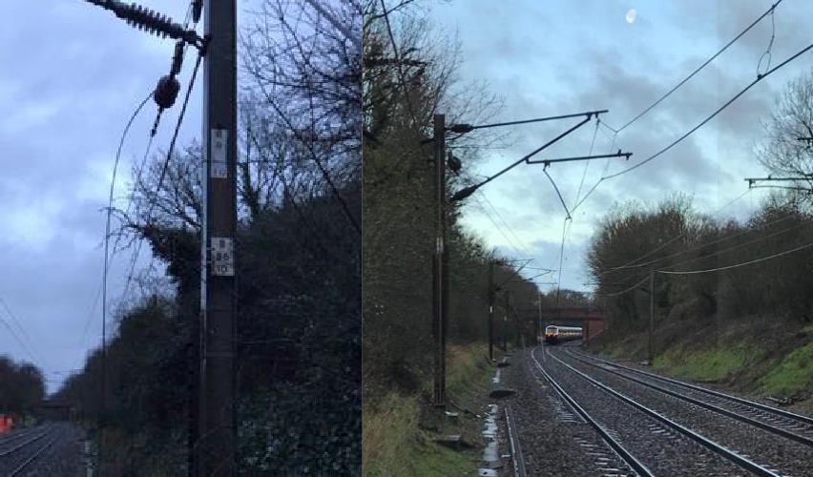

|  |  |  |  |  |  |  |  |
| --- | --- | --- | --- | --- | --- | --- | --- |
| TRUST 775935 IQHM | | | | | | | |
| Cancelled | 76 | Part Cancelled | 50 | Trains Delayed | 270 | Minutes | 3437 |

***22 WEATHER-RELATED PROBLEMS (CONT.)***

# Southern (Sussex) – CCIL 2078442 / Fault No. 158479

At 0733 the Redhill Mobile Operations Manager, who was undertaking embankment checks at an existing slip site at Cookspond Viaduct, (15/01/20) between East Grinstead and Dormans, reported further movement of the slip site with the passage of trains. Both lines were blocked pending further inspection by Earthworks staff with specialist contractors requested to attend. A bus replacement service was initiated between Hurst Green and East Grinstead. At 1054 Earthworks staff reported that the site had been inspected and confirmed the Down East Grinstead line could be reopened for single line working if required, the Up East Grinstead line will remain closed until further notice.

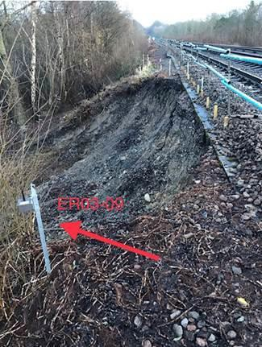

|  |  |  |  |  |  |  |  |
| --- | --- | --- | --- | --- | --- | --- | --- |
| TRUST 777068 IQBH | | | | | | | |
| Cancelled | 13 | Part Cancelled | 77 | Trains Delayed | 183 | Minutes | 1195 |

***23 FIRES***

None.

***24 WILD REPORTS & HABD ACTIVATIONS***

# Disconnected Hot Axle Box Detectors:

|  |  |  |  |  |  |  |  |  |  |
| --- | --- | --- | --- | --- | --- | --- | --- | --- | --- |
| *Region / Route* | *Location* | *Line* | *Date Disconnected* | *Reason* | *TOC’s/ FOC’s*  *advised* | *Planned Restoration Date* | *Date Restored* | *Function* | *Fault Number* |
| Eastern (Anglia) | Brentwood | Down Electric | 10/03/16 | Offline | Y | Awaiting update |  | IM | 234632 |
| Eastern (Anglia) | Brentwood | Down Main | 10/03/16 | Offline | Y | Awaiting update |  | IM | 234632 |
| Eastern (Anglia) | Margaretting | Up Main | 19/09/19 |  | Y | Awaiting update |  | IM | 298498 |
| **Eastern (EM)** | **East Langton** | **Down and Up Main** | **12/02/20** | **Off line alarm** | **Y** | **Awaiting update** |  | **IM** | **154160** |
| Eastern (EM) | Chiltern Green | Down Slow | 11/07/19 | Defective | Y | Awaiting update |  |  | 148559 |
| Eastern (EM) | Napsbury | Up Fast | 11/07/19 | Defective | Y | Awaiting update |  |  | 148559 |
| **Eastern (EM)** | **Langley Mill** | **Up & Down Erewash Slow** | **13/02/20** | **SK4 fault** | **Y** | **Waiting update** |  | **IM** | **1564199** |
| Eastern (LNE) | Barkston | Up Main | 01/04/19 | Removed for P’Way work | Y | Awaiting update |  |  |  |
| NW & Central (NW) | Bolton-le- Sands | Up Main | 25/08/19 | Integrity Fault | Y | Awaiting update |  |  | 863361 |
| NW & Central (NW) | Hest Bank | Up Main | 25/08/19 | Integrity Fault | Y | Awaiting update |  |  | 863360 |
| NW & Central (NW) | Low Mill | Down Main | 26/11/14 | Awaiting replacement | Y | Awaiting update |  | IP | 671852 |
| NW & Central (NW) | Sutton Weaver | Down Main |  |  | Y | Awaiting update |  |  |  |
| NW & Central (WCMLS) | Bradnocks Marsh (Coventry) | Up Main | 29/12/19 | Integrity | Y | Awaiting Update |  |  | 872142 |
| NW & Central (WCMLS) | Castlethorpe | Up Fast | 27/11/18 | Error code 6.0 | Y | Awaiting Update |  | IM | 832410 |
| NW & Central (WCMLS) | Harecastle | Up Main | 01/04/19 | Rail incorrectly drilled | Y | Awaiting Update |  |  |  |
| NW & Central (WCMLS) | Penkridge | Up Penkridge | 04/11/19 | Integrity | Y | Awaiting Update |  |  | 870982 |
| **NW & Central (WCMLS)** | **Spetchley** | **DG** | **29/12/19** | **Integrity** | **Y** | **Awaiting Update** | **13/02/20** |  |  |
| Wales & Western (Wales) | Dainton | Down Main | 17/11/19 | Defective PC | Y | Awaiting Update |  | IM | 453850 |
| Wales & Western (Western) | Cogload | Down Main | 25/01/20 |  | Y |  |  |  | 458740 |
| Wales & Western (Western) | Treverrin | Down Main | 01/07/19 |  | Y | Awaiting Update |  |  | 443474 |
| Wales & Western (Western) | Twerton | Down Main | 19/11/19 |  | Y | Awaiting Update |  |  | 454030 |
| Wales & Western (Western) | Warminster | Up Salisbury | 22/01/20 | Defective | Y | Awaiting Update |  |  | 458111 |

**Disconnected Wheel Impact Load Detectors:**

|  |  |  |  |  |  |  |  |  |  |
| --- | --- | --- | --- | --- | --- | --- | --- | --- | --- |
| *Region / Route* | *Location* | *Line* | *Date Disconnected* | *Reason* | *TOC’s/ FOC’s*  *advised* | *Planned Restorati on Date* | *Date Restored* | *Function* | *Fault Number* |
| Eastern (EC) | Sessay | Up Slow | 18/06/2019 | Calibration |  |  |  | IM |  |
| North West & Central (NW) | Heaton Chapel | Up Slow | 30/07/2019 | Calibration |  |  |  | IM |  |
| Southern (Kent) | Sevington | Down Main | 25/04/2018 | PC Failure |  |  |  | IM |  |
| Southern (Kent) | Sevington | Up Main | 09/08/2018 | PC Failure |  |  |  | IM |  |
| Southern (Kent) | Swanley | Up Slow | 02/04/2019 | Calibration |  |  |  | IM |  |
| Scotland | Howwood | Up | 20/01/2019 | HOBC |  |  |  | IM |  |
| Wales & Western (Western) | Urchfont | Up | 11/04/2019 | PC Failure |  |  |  | IM |  |
| Wales & Western (Western) | Urchfont | Down | 11/04/2019 | PC Failure |  |  |  | IM |  |

***25 GROUP STANDARDS GE/RT8250 & GO/RT3350***

None.

***26 TPWS***

|  |  |  |  |  |  |  |  |  |
| --- | --- | --- | --- | --- | --- | --- | --- | --- |
| ***Region*** | ***Route*** | ***Train*** | ***Signal/PSR/ Buffer Stop*** | ***Line/Platform*** | ***Location*** | ***Speed (reported)*** | ***Speed (set)*** | ***CCIL*** |
| Southern | Wessex | 2G09 South Western Railway 0703 Waterloo - Guildford | W225 | Down Slow | New Malden | 50 | 41.5 | 2093960 |
| W&W | Westrn | 2C77, Great Western Railway, Cardiff Central – Penzance | 60 PSR | Down Main | Teignmouth | 85 | 60 | 2093612 |
| Southern | Wessex | 2T64, South Western Railway, 2059 Portsmouth Harbour  – London Waterloo | 20 PSR | Up Portsmouth | Fareham | 57.46 | 52 | 2094325 |

***27 MISCELLANEOUS***

# North West and Central (WCMLS) - CCIL 2093991

At 0851, West Midlands Trains reported that a driver turn was uncovered, this resulted in significant issues with departures from Kings Heath Depot affected. Significant reactionary delays ensued.

|  |  |  |  |  |  |  |  |
| --- | --- | --- | --- | --- | --- | --- | --- |
| TRUST 775962 TEJ4 | | | | | | | |
| Cancelled | 2 | Part Cancelled | 3 | Trains Delayed | 155 | Minutes | 1410 |

# Eastern (Anglia) – CCIL 2094292

2L99, Arriva Rail London, 1650 Clapham Junction – Stratford was terminated on arrival at Hackney Wick at 1816, 30 minutes late. It was advised that the service had encountered increased passenger loading due to an earlier failed train, with assistance sought from station staff at Homerton for a safe dispatch. Significant reactionary delay ensued.

|  |  |  |  |  |  |  |  |
| --- | --- | --- | --- | --- | --- | --- | --- |
| TRUST 777784 TEKA | | | | | | | |
| Cancelled | 2 | Part Cancelled | 7 | Trains Delayed | 67 | Minutes | 587 |

***28 REVIEW TABLE***

|  |  |  |
| --- | --- | --- |
| ***INCIDENT*** | ***TODAY’S TOTAL*** | ***DAYS SINCE LAST INCIDENT*** |
| **PASSENGER ACCIDENTAL FATALITIES** | **0** | **436** |
| **RAILWAY WORKFORCE FATALITIES** | **0** | **62** |
| **SIGNALS PASSED AT RED (CATEGORY ‘A’)** | **0** | **1** |
| **SIGNALS PASSED AT DANGER (ERROR/TECHNICAL SIGNAL REVERSION)** | **1** | **0** |
| **DERAILMENTS** | **0** | **6** |
| **TRAIN COLLISIONS** | **0** | **1** |
| **TRAINS STRIKING ROAD VEHICLES** | **0** | **17** |
| **ENVIRONMENTAL INCIDENTS** | **0** | **3** |

***29 REAL TIME PERFORMANCE FIGURES***

